Hotel Reservation Form
Hangzhou Lakeview Hotel
No. 2 Huancheng West Road，Gongshu District, Hangzhou, Zhejiang 310006, China
Email: reservation@hzlakeviewhotel.com, with a copy to:info-scwestpac16@sio.org.cn; n.saransuth@unesco.org
Name:__________________________ Institution:______________________________
Room Picture | Preferred Room Type & Bed Preference  (Please tick one box) | Number of rooms | Check-in Date | Check-out Date
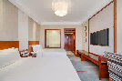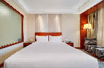 | Superior Room  (1 Queen Bed/2 Single Beds)  Discounted rate: ¥500/night (approx. USD74.4)  Room Floor: Floors 2-3; Room Area: 25㎡; Non-smoking  Breakfast for two included
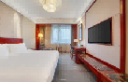 | City View Room  (1 Queen Bed/2 Single Beds)  Discounted rate: ¥500/night (approx. USD74.4)  Room Floor: Floor 4-7; Room Area: 25㎡; Non-smoking  Breakfast for two included
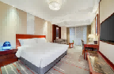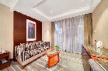 | Balcony Room  (1 Queen Bed/2 Single Beds)  Discounted rate: ¥800/night (approx. USD119.04)  Room Floor: Floor 2-3; Room Area: 28-30㎡; Non-smoking  Breakfast for two included
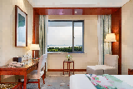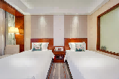 | Lake View Room  (1 Queen Bed/2 Single Beds)  Discounted rate: ¥1,000/night (approx. USD148.80)  Room Floor：Floor 6-7; Room Area：25㎡; Non-smoking  Breakfast for two included

