Annex 1
Kickoff Workshop on
Blue Carbon Ecosystem Restoration in the Western Pacific

Advancing science, sharing practices, and building cooperation for
a healthier coastal future

Xiamen, China, 6-8 November 2025
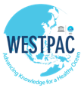




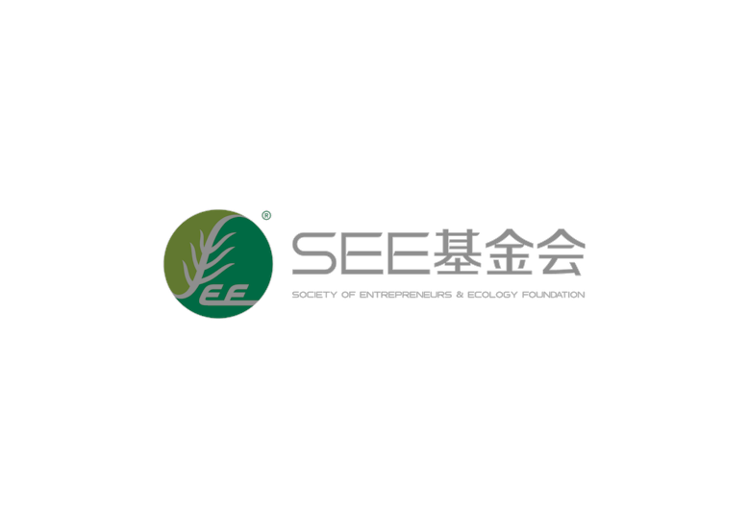

REGISTRATION/APPLICATION FORM

First name
Family name
Gender |  | Male Female
Nationality
Date of birth
Organization
Job position
Years of working experience
Phone number (optional)
Email address
Contact person (email and mobile number), in case of emergency
Dietary restrictions |  | None No pork No beef  Other, please specify
Major work / research Area
Any other workshop(s) you attended related to this topic |  | No Yes, please specify the workshop titles:  (a)  (b)
Please provide a brief description of your research activities and work experience relevant to this workshop, and related publication if any. If you joined previous WESTPAC workshops, please also brief here.
(This part is crucial for qualifying)

Please provide the contact details of your referee for your application:
Referee | Name
Referee | Job Title
Referee | Organization
Referee | Email
Financial assistance
Please select one option:
I will cover all my own expenses (airfare and local accommodation)
I would like to request financial assistance for airfare only
I would like to request financial assistance for local accommodation only
I would like to request financial assistance for both airfare and local accommodation

Important: If you are applying for financial assistance, please also attach your CV when submitting this form.

Signature: ………………………. Date: ……………………………….

Please complete this offline registration form and email it to iocwestpac@unesco.org with the subject line: Registration/Application Form - Blue Carbon Ecosystem Restoration Workshop, before 31 August 2025.

